Contents

Q1 : 2

Q2: 3

Q4. 5

# Q1 :

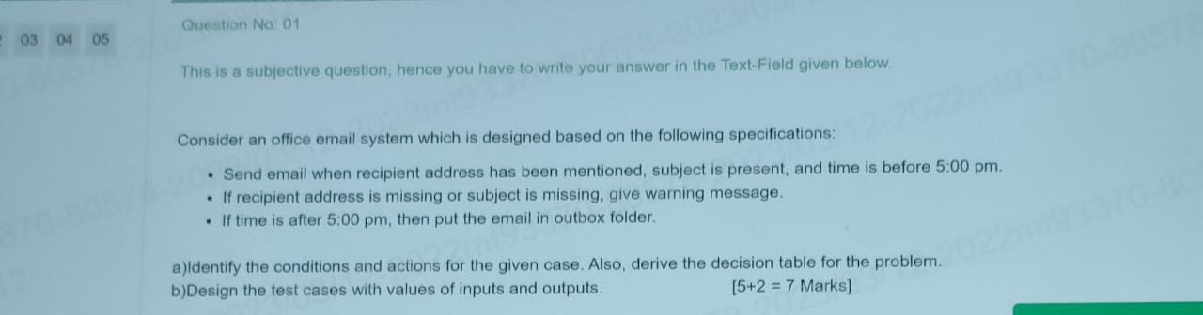

A :

C1 : recipient address present

C2 : subject is present

C3 : time < 5:00 PM

A1 : send email

A2 : warning message

A3 : outbox folder

A4 : impossible

|  |  |  |  |  |  |  |  |  |
| --- | --- | --- | --- | --- | --- | --- | --- | --- |
| Conditions | Rule1 | Rule2 | Rule3 | Rule4 | Rule5 | Rule6 | Rule7 | Rule8 |
| C1 | F | T | T | T | T | F | F | F |
| C2 | F | T | F | F | T | T | F | T |
| C3 | F | T | F | T | F | T | T | F |
| Actions |  |  |  |  |  |  |  |  |
| A1 |  | T |  |  |  |  |  |  |
| A2 |  |  | T | T |  | T | T | T |
| A3 |  |  | T |  | T |  |  | T |
| A4 | T |  |  |  |  |  |  |  |

2^n – n is rules

2^3(conditions) = 2*2*2= 8 (Rules)

B :

TC 1: Email should be valid email address

TC 2: Mail should sent before 5:00PM

Tc 3: Subject should not be empty

Tc 4: If mail is sent after 5:00 PM, then mail should be stored in outbox

Tc 5:

…

# Q2:

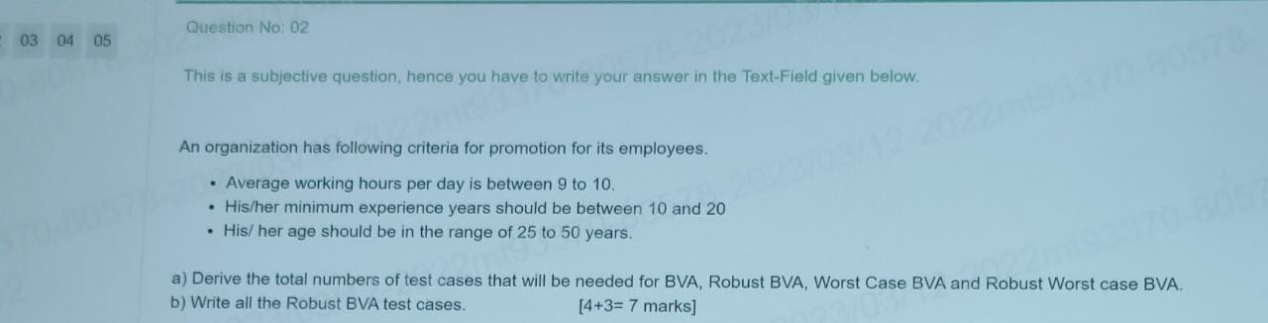

Sol:

a)

BVA=4n + 1 = 13

Robust BVA = 6n +1 = 19

Worst case BVA= 5^n +1 = 126

Robust Worst case BVA= 7^n = 343

* n = number of inputs
* Here n is 3 (conditions)

b)

Robust BVA

<https://t4tutorials.com/what-is-robust-case-testing-software-testing/#google_vignette>

BVA

<https://t4tutorials.com/what-is-simple-boundary-value-testing-software-testing/>

|  |  |  |  |  |
| --- | --- | --- | --- | --- |
|  |  |  |  |  |
|  | X (working hours) | Y (experience) | Z (age) |  |
| Min- | 08:45 | 9 | 24 |  |
| Min | 09:00 | 10 | 25 |  |
| Min + | 09:15 | 11 | 26 |  |
| Nominal | 09:30 | 15 | 37 |  |
| Max- | 09:45 | 19 | 49 |  |
| Max | 10:00 | 20 | 50 |  |
| Max + | 10:15 | 21 | 51 |  |
|  |  |  |  |  |
|  |  |  |  |  |
|  |  |  |  |  |
|  |  |  |  |  |
| Test case | X (working hours) | Y (experience) | Z (age) | Expected output |
| 1 | 09:30 | 15 | 24 | Not promoted |
| 2 | 09:30 | 15 | 25 | Promoted |
| 3 | 09:30 | 15 | 26 | Promoted |
| 4 | 09:30 | 15 | 37 | Promoted |
| 5 | 09:30 | 15 | 49 | Promoted |
| 6 | 09:30 | 15 | 50 | Promoted |
| 7 | 09:30 | 15 | 51 | Not promoted |
| 8 | 09:30 | 9 | 37 | Not promoted |
| 9 | 09:30 | 10 | 37 | Promoted |
| 10 | 09:30 | 11 | 37 | Promoted |
| 11 | 09:30 | 19 | 37 | Promoted |
| 12 | 09:30 | 20 | 37 | Promoted |
| 13 | 09:30 | 21 | 37 | Not promoted |
| 14 | 08:45 | 15 | 37 | Not promoted |
| 15 | 09:00 | 15 | 37 | Promoted |
| 16 | 09:15 | 15 | 37 | Promoted |
| 17 | 09:45 | 15 | 37 | Promoted |
| 18 | 10:00 | 15 | 37 | Promoted |
| 19 | 10:15 | 15 | 37 | Not promoted |

Based on below diagram we have to write test case, for eg:

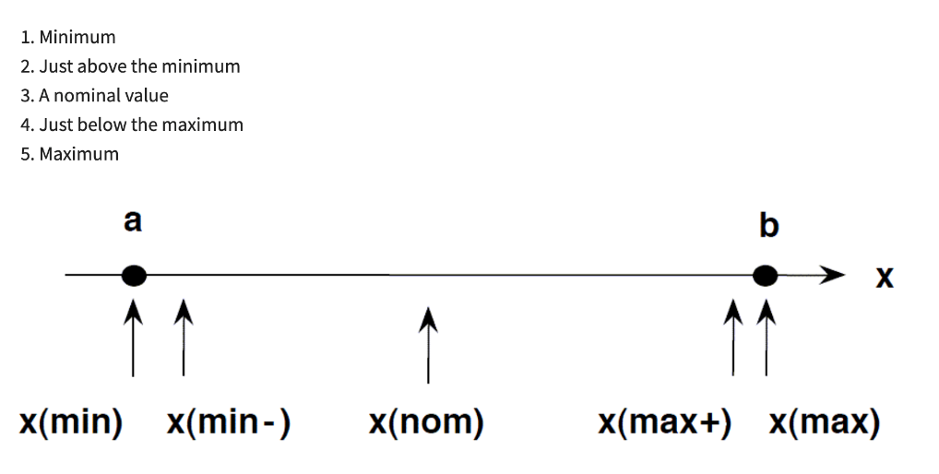

# Q4.

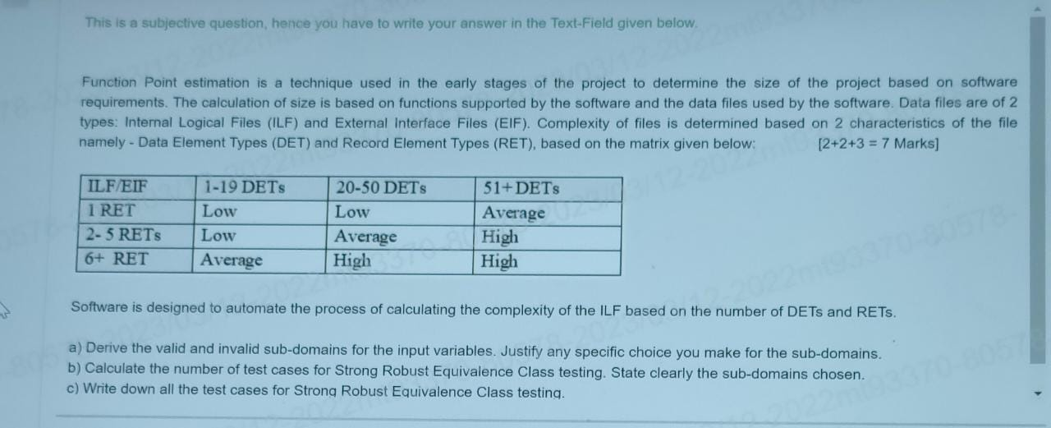

Sol:

1. Valid subdomains :

|  |  |  |  |
| --- | --- | --- | --- |
| Sl.no | Input paramters | Valid subdomains | Invalid Subdomains |
| 1 | RET | 1=RET | RET<1 |
|  |  | 2<=RET<=5 | 1<RET<2 |
|  |  | 6<=RET | 5<RET<6 |
| 2 | DET | 1<=DET<=19 | DET<1 |
|  |  | 20<=DET<=50 | 19<DET<20 |
|  |  | 51<=DET | 50<DET<51 |

1. Number of test cases for Strong robust :

27

